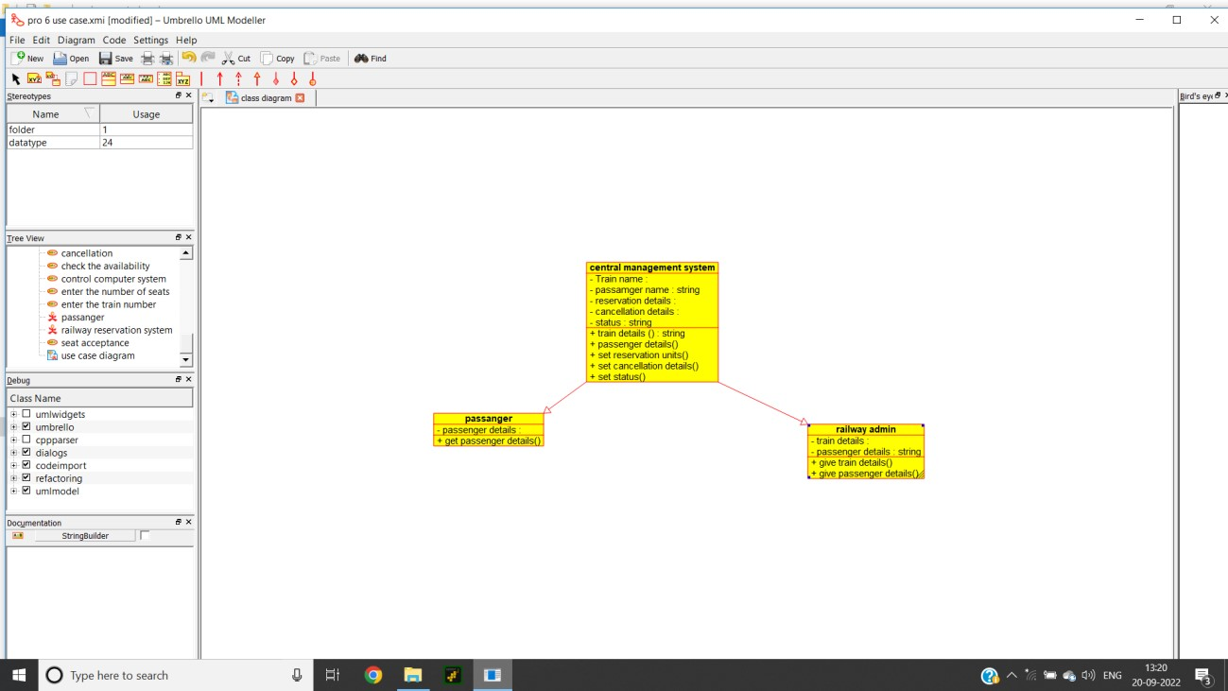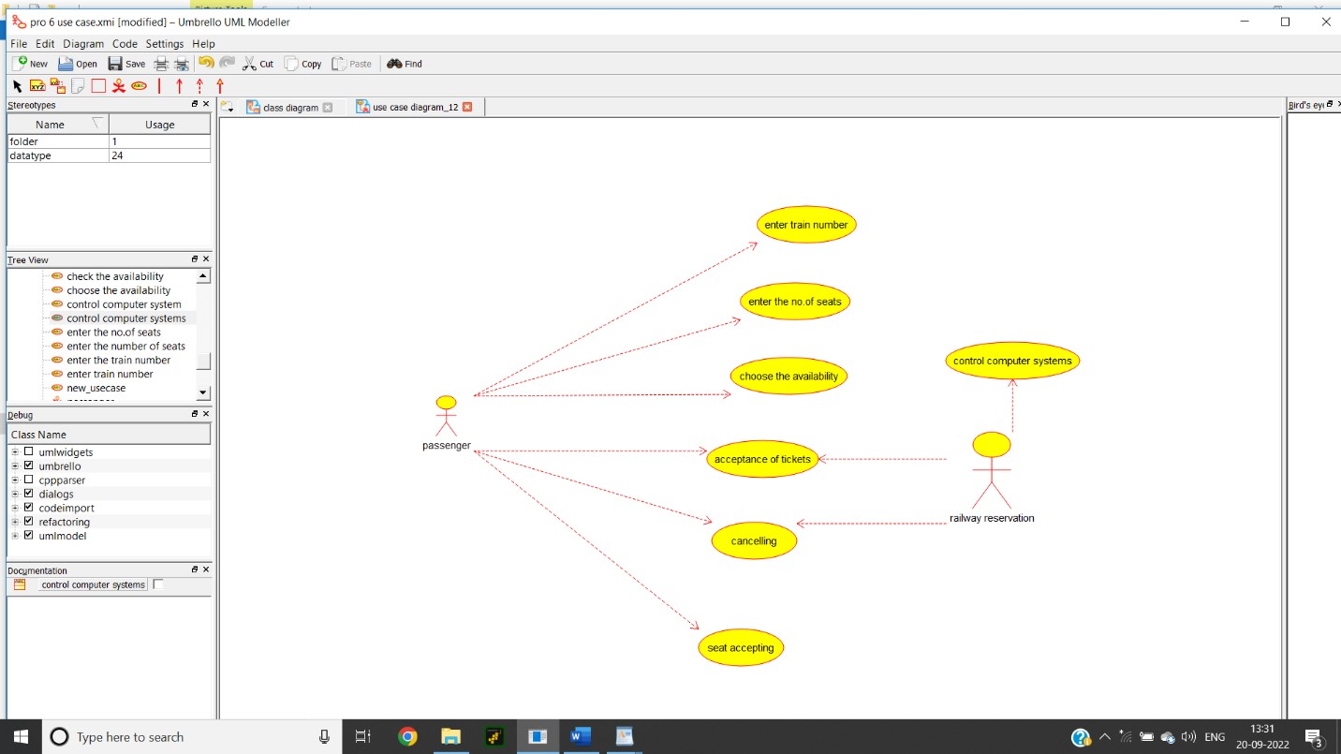

**Source Code:**

/**

* Class passanger

*/

public class passanger {

//

// Fields

//

private void passenger_details;

//

// Constructors //

public passanger () { };

//

// Methods

//

//

// Accessor methods

//

/**

* Set the value of passenger_details
* @param newVar the new value of passenger_details

*/

private void setPassenger_details (void newVar) { passenger_details = newVar;

}

/**

* Get the value of passenger_details
* @return the value of passenger_details

*/

private void getPassenger_details () { return passenger_details;

}

//

// Other methods

//

/** */

public void get_passenger_details()

{

}

}

/**

* Class central_management_system

*/

public class central_management_system extends passanger, railway_admin {

//

// Fields

// private void Train_name; private String passamger_name; private void reservation_details; private void cancellation_details; private String status;

//

// Constructors

//

public central_management_system () { };

//

// Methods

//

//

// Accessor methods

//

/**

* Set the value of Train_name
* @param newVar the new value of Train_name

*/

private void setTrain_name (void newVar) {

Train_name = newVar;

}

/**

* Get the value of Train_name
* @return the value of Train_name

*/

private void getTrain_name () {

return Train_name;

}

/**

* Set the value of passamger_name * @param newVar the new value of passamger_name

*/

private void setPassamger_name (String newVar) { passamger_name = newVar;

}

/**

* Get the value of passamger_name
* @return the value of passamger_name

*/

private String getPassamger_name () { return passamger_name;

}

/**

* Set the value of reservation_details
* @param newVar the new value of reservation_details

*/

private void setReservation_details (void newVar) { reservation_details = newVar;

}

/**

* Get the value of reservation_details
* @return the value of reservation_details

*/

private void getReservation_details () { return reservation_details;

}

/**

* Set the value of cancellation_details
* @param newVar the new value of cancellation_details

*/

private void setCancellation_details (void newVar) { cancellation_details = newVar;

}

/**

* Get the value of cancellation_details
* @return the value of cancellation_details

*/

private void getCancellation_details () { return cancellation_details;

}

/**

* Set the value of status
* @param newVar the new value of status

*/

private void setStatus (String newVar) { status = newVar;

}

/**

* Get the value of status
* @return the value of status

*/

private String getStatus () { return status;

}

//

// Other methods

//

/**

* @return String

*/

public String train_details_()

{

}

/** */

public void passenger_details()

{

}

/** */

public void set_reservation_units()

{

}

/** */

public void set_cancellation_details()

{

}

/** */ public void set_status() {

}

}

/**

* Class railway_admin

*/

public class railway_admin {

//

// Fields

// private void train_details; private String passenger_details;

//

// Constructors //

public railway_admin () { };

//

// Methods

//

//

// Accessor methods

//

/**

* Set the value of train_details * @param newVar the new value of train_details

*/

private void setTrain_details (void newVar) { train_details = newVar;

}

/**

* Get the value of train_details
* @return the value of train_details

*/

private void getTrain_details () { return train_details;

}

/**

* Set the value of passenger_details
* @param newVar the new value of passenger_details

*/

private void setPassenger_details (String newVar) { passenger_details = newVar;

}

/**

* Get the value of passenger_details
* @return the value of passenger_details

*/

private String getPassenger_details () { return passenger_details;

}

//

// Other methods

//

/** */

public void give_train_details()

{ }

/** */

public void give_passenger_details()

{

}

}